Ideation Phase
Define the Problem Statement

Date | 25 November 2025
Team ID
Project Name | DocSpot
Maximum Marks | 2 Marks

Problem statement:
Patients often struggle to find the right doctors, check their availability, and book appointments without unnecessary delays. Most clinics still rely on manual or outdated scheduling systems, which lead to miscommunication, long waiting times, and a lack of transparency in appointment management. Doctors also face difficulties managing their schedules efficiently, while administrators handle repetitive tasks without a centralized digital platform. This results in frustration for patients, inefficiency for doctors, and operational challenges for clinic staff. DocSpot aims to solve these issues by providing a seamless, real-time, and user-friendly appointment booking system.

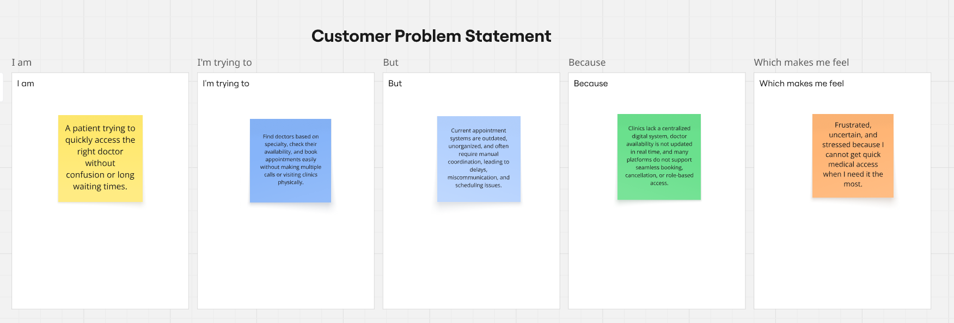

Customer Problem Statement 1: Patient

I am
A patient looking for quick and reliable access to the right doctor.

I’m trying to
Book appointments easily, check doctor availability, and avoid long clinic waiting times or repeated phone calls.

But
Most clinics use manual or outdated systems that cause delays, confusion, and difficulty finding the right specialist.

Because
There is no centralized digital platform that shows real-time availability, doctor details, or quick booking options.

Which makes me feel
Frustrated, stressed, and uncertain about when I can actually see a doctor.

Customer Problem Statement 2: Doctor

I am
A doctor trying to manage my consulting schedule and patient appointments efficiently.

I’m trying to
Organize appointments, reduce no-shows, and view all bookings in one place without depending on staff updates.

But
Manual scheduling leads to miscommunication, double bookings, and time conflicts with clinic and online consultations.

Because
There is no automated system that syncs schedules, manages appointments, or provides easy access to patient booking details.

Which makes me feel
Overloaded, unorganized, and unable to provide a smooth experience for my patients.

